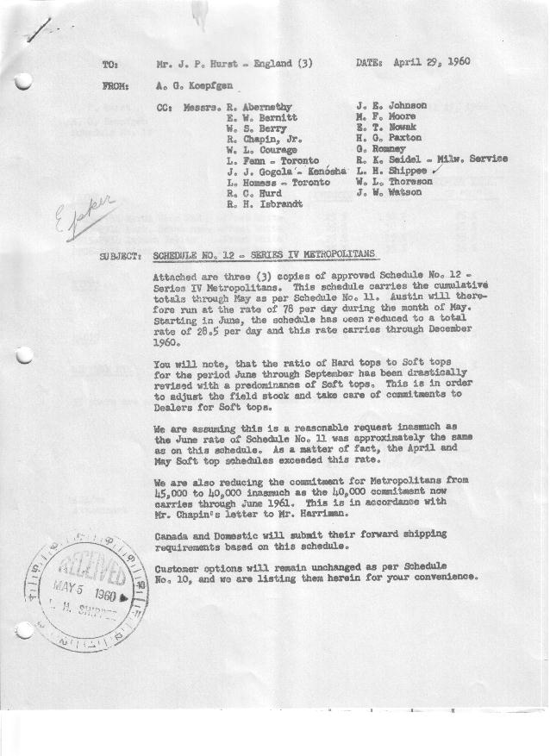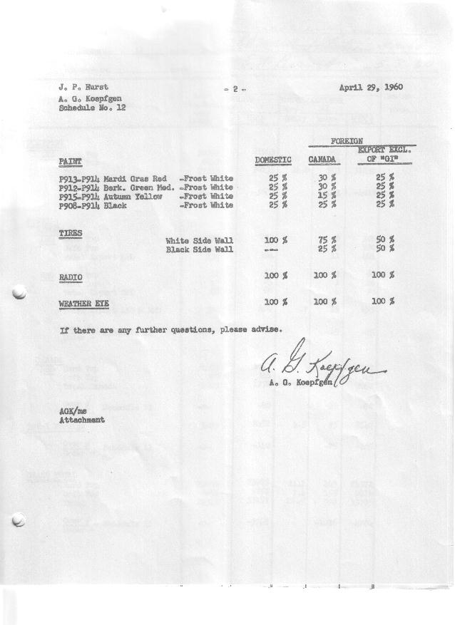

FORM AM 1262 Page 1 of 3 APPROVED R. Abernethy (signed) DATE 5-2-60

SCHEDULE NO. ______12 ___ DATE 4-29-60 MONTHLY BUILDING SCHEDULE APPROVED R. W.Chapin Jr. (signed) DATE_ 5-3-60 _
REVISION NO. _______ __ ____ DATE PRODUCT APPROVED E.W.Bernitt (signed) DATE _ 5-3-60 ___
SERIES IV 1500 c.c. ENGINE
METROPOLITAN SERIES CARS – AUSTIN MOTORS CO., LTD, ENGLAND
DESCRIPTION | BUILT  ◻ACT EST  THRU  APRIL | FIRM BUILDING SCHEDULE  (FABRICATED MATERIAL RELEASE) |  |  |  |  |  |  |  |  |  |  |  |  |  |  | TENTATIVE SCHEDULE  (RAW MATERIAL RELEASED) |  |  | GRAND  TOTAL
DESCRIPTION | BUILT  ◻ACT EST  THRU  APRIL | MONTH MAY  DAYS 22 |  |  | MONTH JUNE  DAYS 20 |  |  | MONTH JULY  DAYS 16 |  |  | MONTH AUGUST  DAYS 18 |  |  | MONTH SEPTEMBER  DAYS 22 |  |  | MONTH OCTOBER  DAYS 21 |  |  | GRAND  TOTAL
DESCRIPTION | BUILT  ◻ACT EST  THRU  APRIL | DAILY | MONTH | CUM’L  TOTAL | DAILY | MONTH | CUM’L  TOTAL | DAILY | MONTH | CUM’L  TOTAL | DAILY | MONTH | CUM’L  TOTAL | DAILY | MONTH | CUM’L  TOTAL | DAILY | MONTH | CUM’L TOTAL | GRAND  TOTAL
DOMESTIC LHD:
Hard-Top | 20959 |  | 984 | 21943 |  | -0- | 21943 |  | -0- | 21943 |  | -0- | 21943 |  | -0- | 21943 |  | 352 | 22295
Soft-Top | 6259 |  | 651 | 6910 |  | 554 | 7464 |  | 360 | 7824 |  | 427 | 8251 |  | 541 | 8792 |  | 151 | 8943
Total U.S. | 27218 | 74.3 | 1635 | 28853 | 27.7 | 554 | 29407 | 22.5 | 360 | 29767 | 23.8 | 427 | 30194 | 24.6 | 541 | 30735 | 24.0 | 503 | 31238
Over/(Under) Schedule 11 | -0- |  | -0- | -0- |  | (971) | (971) |  | (725) | (1696) |  | (863) | (2559) |  | (1049) | (3608) |  | (1011) | (4619)
FOREIGN:
EXPORT LHD Hard-Top | 251 |  | 14 | 265 |  | 8 | 273 |  | 8 | 281 |  | 8 | 289 |  | 8 | 297 |  | 8 | 305
Soft-Top | 79 |  | 6 | 85 |  | 3 | 88 |  | 3 | 91 |  | 3 | 94 |  | 3 | 97 |  | 3 | 100
Total Export LHD | 330 |  | 20 | 350 |  | 11 | 361 |  | 11 | 372 |  | 11 | 383 |  | 11 | 394 |  | 11 | 405
RHD Hard Top | 42 |  | 7 | 49 |  | 3 | 52 |  | 3 | 55 |  | 3 | 58 |  | 3 | 61 |  | 3 | 64
Soft Top | 18 |  | 3 | 21 |  | 1 | 22 |  | 1 | 23 |  | 1 | 24 |  | 1 | 25 |  | 1 | 26
Total Export RHD | 60 |  | 10 | 70 |  | 4 | 74 |  | 4 | 78 |  | 4 | 82 |  | 4 | 86 |  | 4 | 90
Total Export LHD & RHD | 390 | 1.4 | 30 | 420 | .8 | 15 | 435 | 1.0 | 15 | 450 | .8 | 15 | 465 | .7 | 15 | 480 | .7 | 15 | 495
Over/(Under) Schedule 11 | -0- |  | -0- | -0- |  | (15) | (15) |  | (15) | (30) |  | (15) | (45) |  | (15) | (60) |  | (15) | (75)
CANADA Hard-Top | 1407 |  | -0- | 1407 |  | -0- | 1407 |  | 80 | 1487 |  | 70 | 1557 |  | 70 | 1627 |  | 80 | 1707
Soft-Top | 300 |  | 45 | 345 |  | -0- | 345 |  | -0- | 345 |  | -0- | 345 |  | -0- | 345 |  | -0- | 345
Total Canada | 1707 | 2.0 | 45 | 1752 | 0.0 | -0- | 1752 | 5.0 | 80 | 1832 | 3.9 | 70 | 1902 | 3.2 | 70 | 1972 | 3.8 | 80 | 2052
Over/(Under) Schedule 11 | -0- |  | -0- | -0- |  | -0- | -0- |  | (50) | (50) |  | (10) | (60) |  | (20) | (80) |  | (10) | (90)
Total Foreign | 2097 | 3.4 | 75 | 2172 | .8 | 15 | 2187 | 6.0 | 95 | 2282 | 4.7 | 85 | 2367 | 3.9 | 85 | 2452 | 4.5 | 95 | 2547
Over/(Under) Schedule 11 | -0- |  | -0- | -0- |  | (15) | (15) |  | (65) | (80) |  | (25) | (105) |  | (35) | (140) |  | (25) | (165)
GRAND TOTALS
Hard-Top | 22659 | 45.7 | 1005 | 23664 | .6 | 11 | 23675 | 5.7 | 91 | 23766 | 4.5 | 81 | 23847 | 3.7 | 81 | 23928 | 21.1 | 443 | 24371
Soft-Top | 6656 | 32.0 | 705 | 7361 | 27.9 | 558 | 7919 | 22.8 | 364 | 8283 | 24.0 | 431 | 8714 | 24.8 | 545 | 9259 | 7.4 | 155 | 9414
Total | 29315 | 77.7 | 1710 | 31025 | 28.5 | 569 | 31954 | 28.5 | 455 | 32049 | 28.5 | 512 | 32561 | 28.5 | 626 | 33187 | 28.5 | 598 | 33785
Over/(Under) Schedule 11 | -0- |  | -0- | -0- |  | (986) | (986) |  | (790) | (1776) |  | (888) | (2664) |  | (1084) | (3748) |  | (1036) | (4784)

FORM AM 1262 Page 2 of 3 APPROVED R. Abernethy (signed) DATE 5-2-60

SCHEDULE NO. ______12 ___ DATE 4-29-60 MONTHLY BUILDING SCHEDULE APPROVED R. W.Chapin Jr. (signed) DATE_ 5-3-60 _
REVISION NO. _______ __ ____ DATE PRODUCT APPROVED E.W.Bernitt (signed) DATE _ 5-3-60 ___
SERIES IV 1500 c.c. ENGINE
METROPOLITAN SERIES CARS – AUSTIN MOTORS CO., LTD, ENGLAND
DESCRIPTION | BUILT  ◻ACT◻ EST  THRU | FIRM BUILDING SCHEDULE  (FABRICATED MATERIAL RELEASE) |  |  |  |  |  |  |  |  |  |  |  |  |  |  | TENTATIVE SCHEDULE  (RAW MATERIAL RELEASED) |  |  | GRAND  TOTAL
DESCRIPTION | BUILT  ◻ACT◻ EST  THRU | MONTH NOVEMBER  DAYS 22 |  |  | MONTH DECEMBER  DAYS 21 |  |  | MONTH JANUARY ‘61  DAYS 22 |  |  | MONTH FEBRUARY  DAYS 20 |  |  | MONTH MARCH  DAYS 23 |  |  | MONTH APRIL  DAYS 18 |  |  | GRAND  TOTAL
DESCRIPTION | BUILT  ◻ACT◻ EST  THRU | DAILY | MONTH | CUM’L  TOTAL | DAILY | MONTH | CUM’L  TOTAL | DAILY | MONTH | CUM’L  TOTAL | DAILY | MONTH | CUM’L  TOTAL | DAILY | MONTH | CUM’L  TOTAL | DAILY | MONTH | CUM’L TOTAL | GRAND  TOTAL
DOMESTIC LHD:
Hard-Top |  |  | 379 | 22674 |  | 402 | 23076 |  | 407 | 23483 |  | 355 | 23838 |  | 397 | 24235 |  | 357 | 24592
Soft-Top |  |  | 162 | 9105 |  | 172 | 9277 |  | 408 | 9685 |  | 355 | 10040 |  | 398 | 10438 |  | 238 | 10676
Total U.S. |  | 24.6 | 541 | 31779 | 27.3 | 574 | 32353 | 37.1 | 815 | 33168 | 35.5 | 710 | 33878 | 34.6 | 795 | 34673 | 33.1 | 595 | 35268
Over/(Under) Schedule 11 |  |  | (1061) | (5680) |  | (1020) | (6700) |  | (817) | (7517) |  | (558) | (8075) |  | 795 | (7280) |  | 595 | (6685)
FOREIGN:
EXPORT LHD Hard-Top |  |  | 8 | 313 |  | 8 | 321 |  | 8 | 329 |  | 8 | 337 |  | 8 | 345 |  | 8 | 353
Soft-Top |  |  | 3 | 103 |  | 3 | 106 |  | 3 | 109 |  | 3 | 112 |  | 3 | 115 |  | 3 | 118
Total Export LHD |  |  | 11 | 416 |  | 11 | 427 |  | 11 | 438 |  | 11 | 449 |  | 11 | 460 |  | 11 | 471
RHD Hard Top |  |  | 3 | 67 |  | 3 | 70 |  | 3 | 73 |  | 3 | 76 |  | 3 | 79 |  | 3 | 82
Soft Top |  |  | 1 | 27 |  | 1 | 28 |  | 1 | 29 |  | 1 | 30 |  | 1 | 31 |  | 1 | 32
Total Export RHD |  |  | 4 | 94 |  | 4 | 98 |  | 4 | 102 |  | 4 | 106 |  | 4 | 110 |  | 4 | 114
Total Export LHD & RHD |  | .7 | 15 | 510 | .7 | 15 | 525 | .7 | 15 | 540 | .8 | 15 | 555 | .7 | 15 | 570 | .8 | 15 | 585
Over/(Under) Schedule 11 |  |  | (15) | (90) |  | (15) | (105) |  | (15) | (120) |  | (15) | (135) |  | 15 | (120) |  | 15 | (105)
CANADA Hard-Top |  |  | 70 | 1777 |  | 10 | 1787 |  | 40 | 1827 |  | 60 | 1887 |  | 45 | 1932 |  | 55 | 1987
Soft-Top |  |  | -0- | 345 |  | -0- | 345 |  | 10 | 355 |  | 15 | 370 |  | 65 | 435 |  | 55 | 490
Total Canada |  | 3.2 | 70 | 2122 | 0.5 | 10 | 2132 | 2.2 | 50 | 2182 | 3.7 | 75 | 2257 | 4.7 | 110 | 2367 | 6.1 | 110 | 2477
Over/(Under) Schedule 11 |  |  | (10) | (100) |  | -0- | (100) |  | -0- | (100) |  | -0- | (100) |  | 110 | 10 |  | 110 | 120
Total Foreign |  | 3.9 | 85 | 2632 | 1.2 | 25 | 2657 | 2.9 | 65 | 2722 | 4.5 | 90 | 2812 | 5.4 | 125 | 2937 | 6.9 | 125 | 3062
Over/(Under) Schedule 11 |  |  | (25) | (190) |  | (15) | (205) |  | (15) | (220) |  | (15) | (235) |  | 125 | (110) |  | 125 | 15
GRAND TOTALS
Hard-Top |  | 20.9 | 460 | 24831 | 20.1 | 423 | 25254 | 20.8 | 458 | 25712 | 21.3 | 426 | 26138 | 19.7 | 453 | 26591 | 23.5 | 423 | 27014
Soft-Top |  | 7.6 | 166 | 9580 | 8.4 | 176 | 9756 | 19.2 | 422 | 10178 | 18.7 | 374 | 10552 | 20.3 | 467 | 11019 | 16.5 | 297 | 11316
Total |  | 28.5 | 626 | 34411 | 28.5 | 599 | 35010 | 40.0 | 880 | 35890 | 40.0 | 800 | 36690 | 40.0 | 920 | 37610 | 40.0 | 720 | 38330
Over/(Under) Schedule 11 |  |  | (1086) | (5870) |  | (1035) | (6905) |  | (832) | (7737) |  | (573) | (8310) |  | 920 | (7390) |  | 720 | (6670)

FORM AM 1262 Page 3 of 3 APPROVED R. Abernethy (signed) DATE 5-2-60

SCHEDULE NO. ______12 ___ DATE 4-29-60 MONTHLY BUILDING SCHEDULE APPROVED R. W.Chapin Jr. (signed) DATE_ 5-3-60 _
REVISION NO. _______ __ ____ DATE PRODUCT APPROVED E.W.Bernitt (signed) DATE _ 5-3-60 ___
SERIES IV 1500 c.c. ENGINE
METROPOLITAN SERIES CARS – AUSTIN MOTORS CO., LTD, ENGLAND
DESCRIPTION | BUILT  ◻ACT◻ EST  THRU | FIRM BUILDING SCHEDULE  (FABRICATED MATERIAL RELEASE) |  |  |  |  |  |  |  |  |  |  |  |  |  |  | TENTATIVE SCHEDULE  (RAW MATERIAL RELEASED) |  |  | GRAND  TOTAL
DESCRIPTION | BUILT  ◻ACT◻ EST  THRU | MONTH MAY  DAYS 21 |  |  | MONTH JUNE  DAYS 20.8 (22 Available) |  |  | MONTH  DAYS |  |  | MONTH  DAYS |  |  | MONTH  DAYS |  |  | MONTH  DAYS |  |  | GRAND  TOTAL
DESCRIPTION | BUILT  ◻ACT◻ EST  THRU | DAILY | MONTH | CUM’L  TOTAL | DAILY | MONTH | CUM’L  TOTAL | DAILY | MONTH | CUM’L  TOTAL | DAILY | MONTH | CUM’L  TOTAL | DAILY | MONTH | CUM’L  TOTAL | DAILY | MONTH | CUM’L TOTAL | GRAND  TOTAL
DOMESTIC LHD:
Hard-Top |  |  | 525 | 25117 |  | 535 | 25652
Soft-Top |  |  | 225 | 10901 |  | 230 | 11131
Total U.S. |  | 35.7 | 750 | 36018 | 36.8 | 765 | 36783
Over/(Under) Schedule 11 |  |  | 750 | (5935) |  | 765 | (5170)
FOREIGN:
EXPORT LHD Hard-Top |  |  | 8 | 361 |  | 8 | 369
Soft-Top |  |  | 3 | 121 |  | 3 | 124
Total Export LHD |  |  | 11 | 482 |  | 11 | 493
RHD Hard Top |  |  | 3 | 85 |  | 3 | 88
Soft Top |  |  | 1 | 33 |  | 1 | 34
Total Export RHD |  |  | 4 | 118 |  | 4 | 122
Total Export LHD & RHD |  | .7 | 15 | 600 | .8 | 15 | 615
Over/(Under) Schedule 11 |  |  | 15 | (90) |  | 15 | (75)
CANADA Hard-Top |  |  | 55 | 2042 |  | 50 | 2092
Soft-Top |  |  | 20 | 510 |  | -0- | 510
Total Canada |  | 3.6 | 75 | 2552 | 2.4 | 50 | 2602
Over/(Under) Schedule 11 |  |  | 75 | 195 |  | 50 | 245
Total Foreign |  | 4.3 | 90 | 3152 | 3.2 | 65 | 3217
Over/(Under) Schedule 11 |  |  | 90 | 105 |  | 65 | 170
GRAND TOTALS
Hard-Top |  | 28.1 | 591 | 27605 | 28.7 | 596 | 28201
Soft-Top |  | 11.9 | 249 | 11565 | 11.3 | 234 | 11799
Total |  | 40.0 | 840 | 39170 | 40.0 | 830 | 40000
Over/(Under) Schedule 11 |  |  | 840 | (5830) |  | 830 | (5000)

